TOAL ACTIVE POWER [MW] WeatherType Present

0 0.032324 Weather_Broken clouds 0

1 0.032324 Weather_Broken clouds 0

2 0.032324 Weather_Broken clouds 0

3 0.032324 Weather_Broken clouds 0

4 0.032324 Weather_Broken clouds 0  
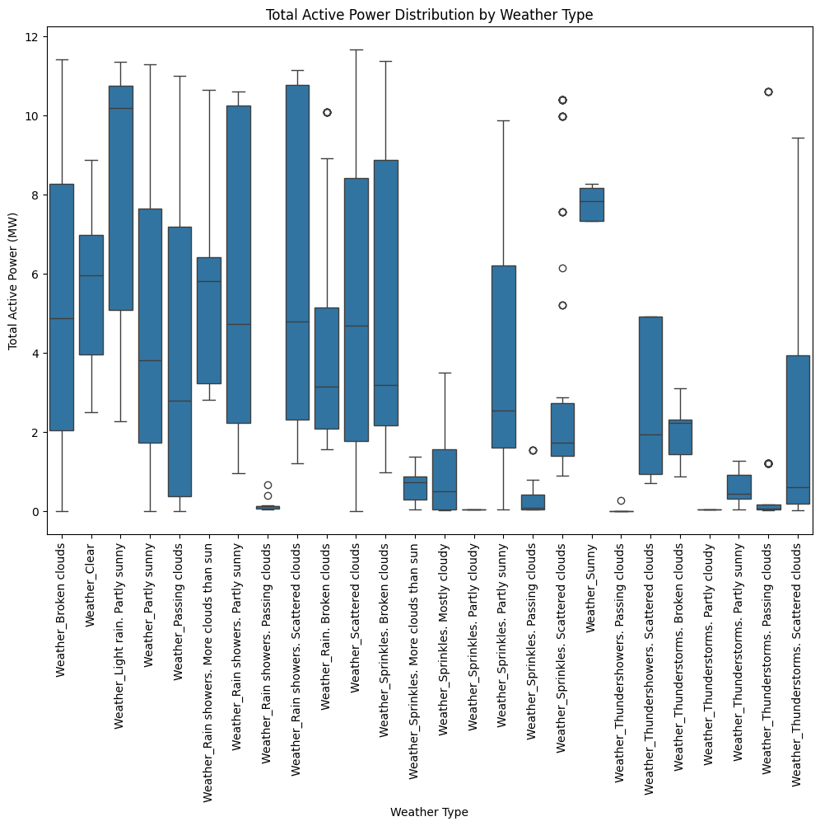

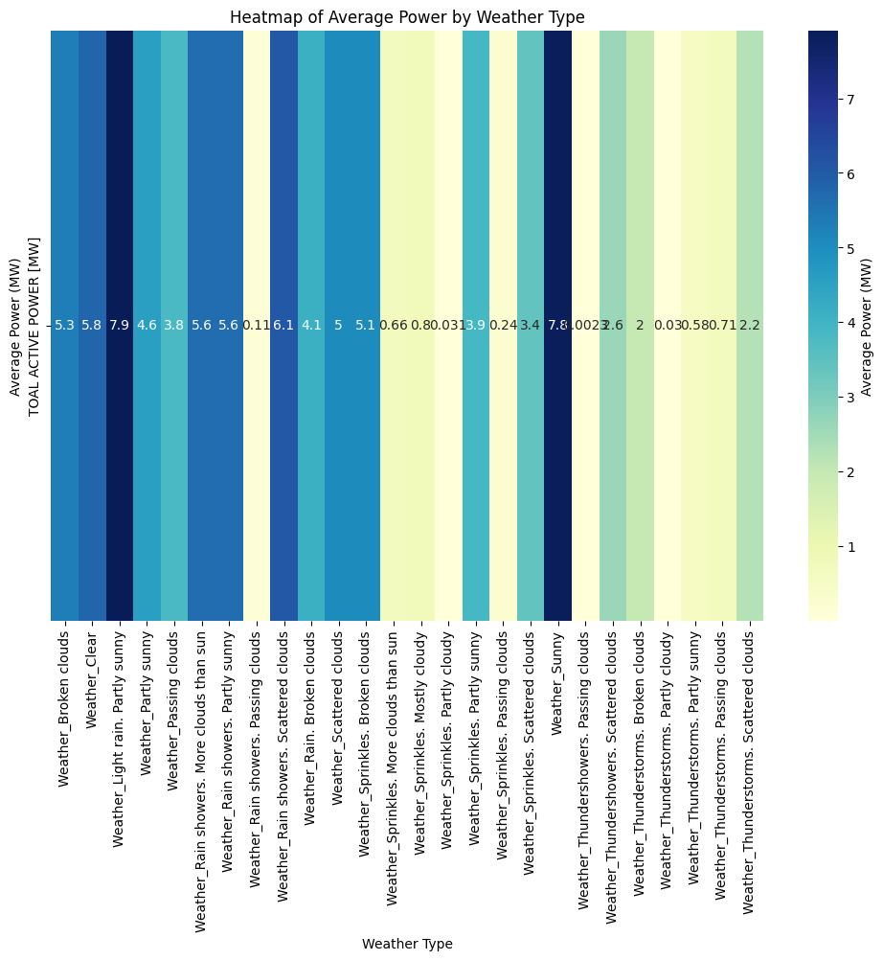

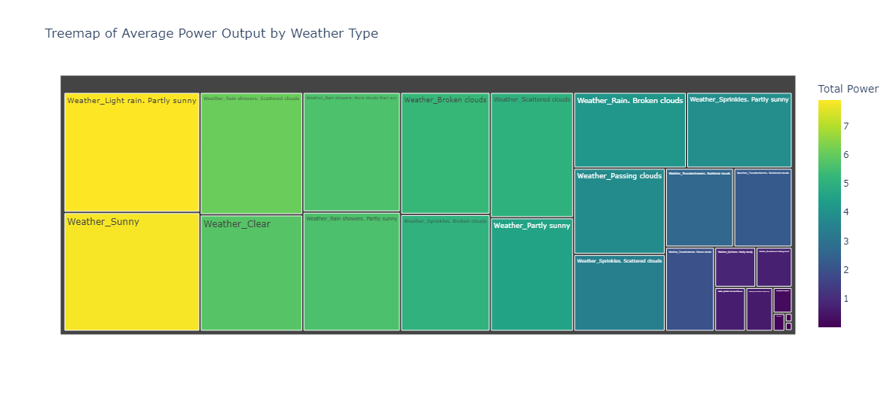

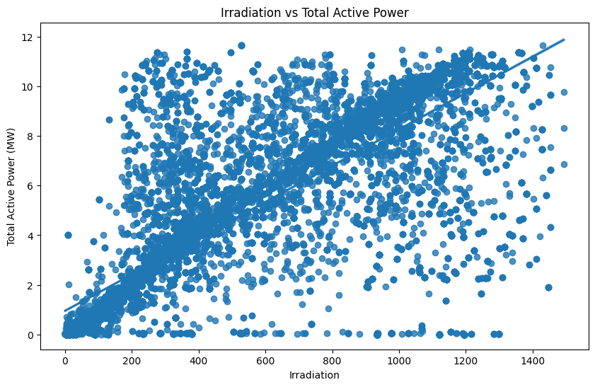

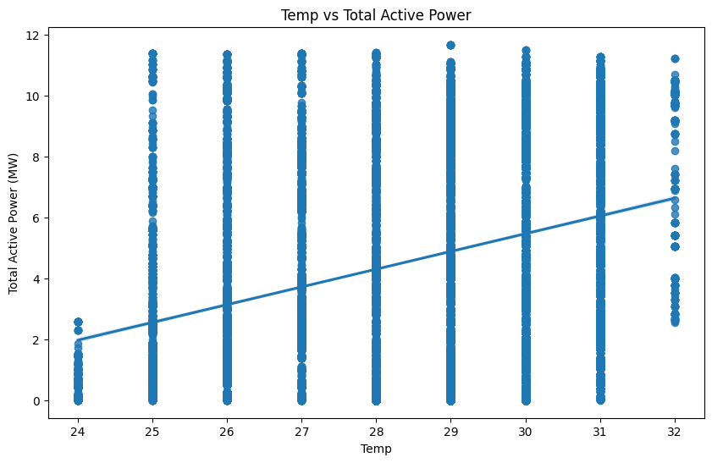

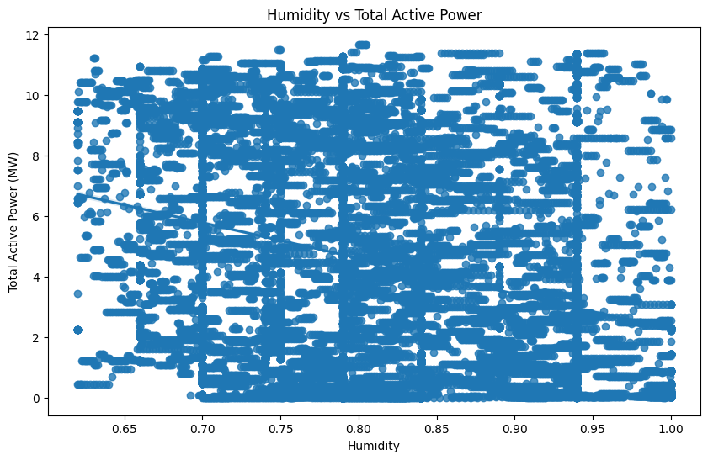

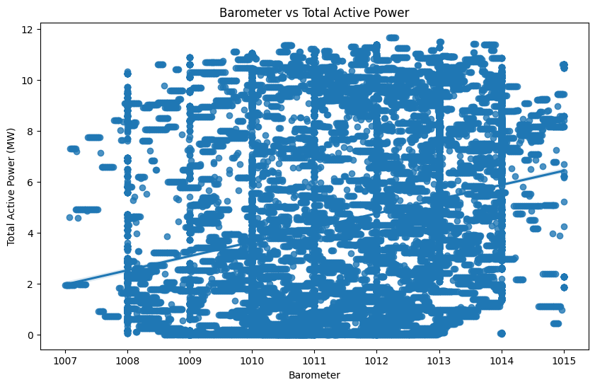

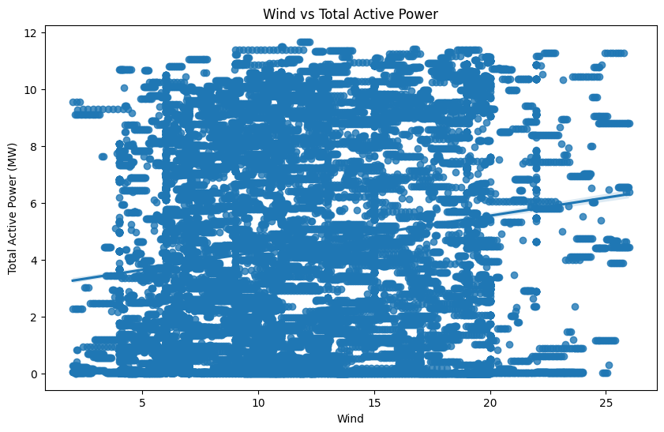

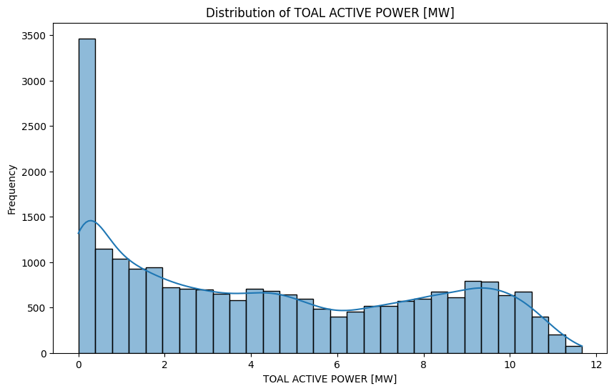

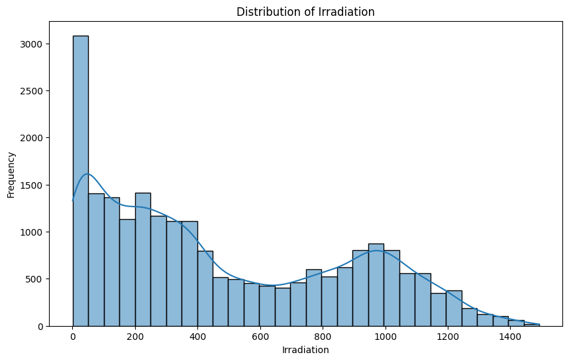

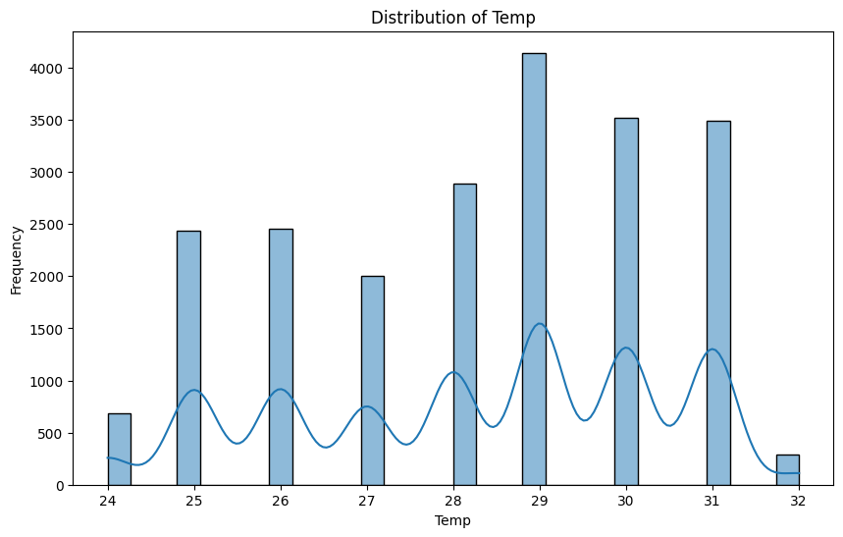

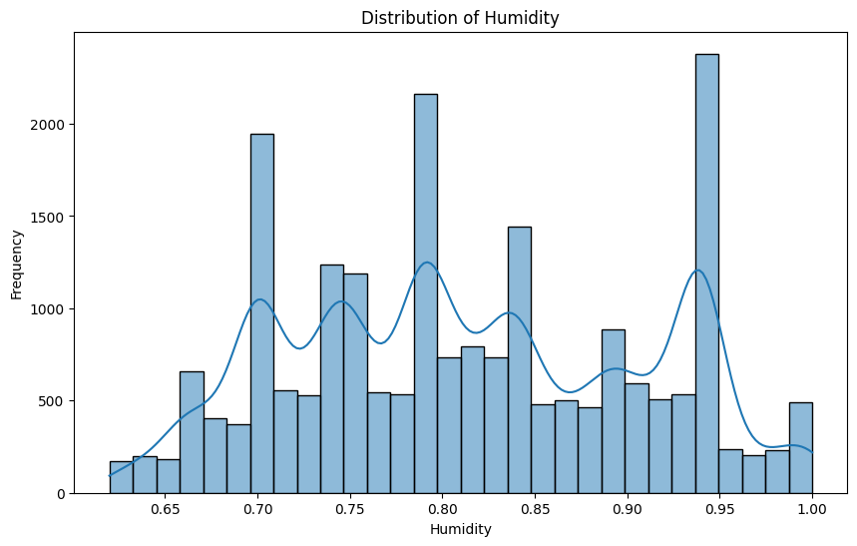

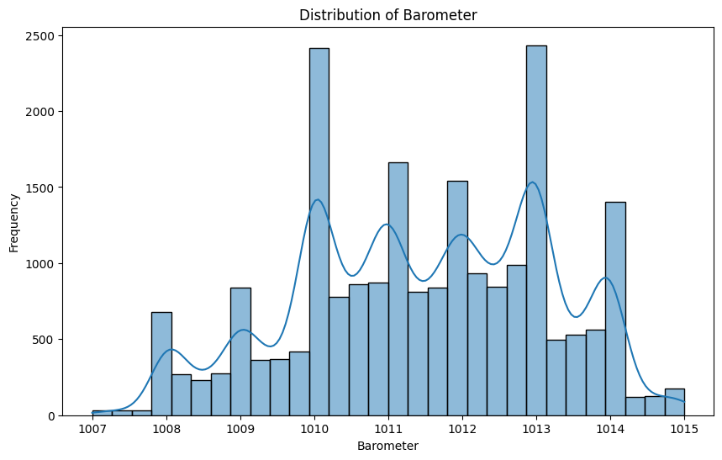

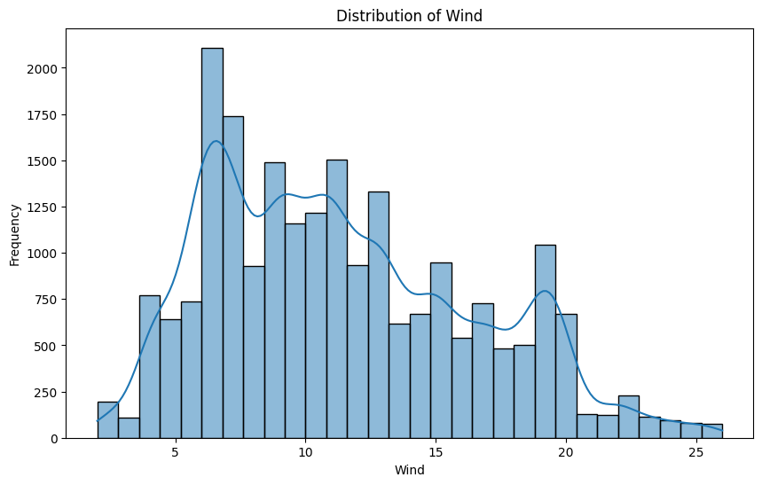

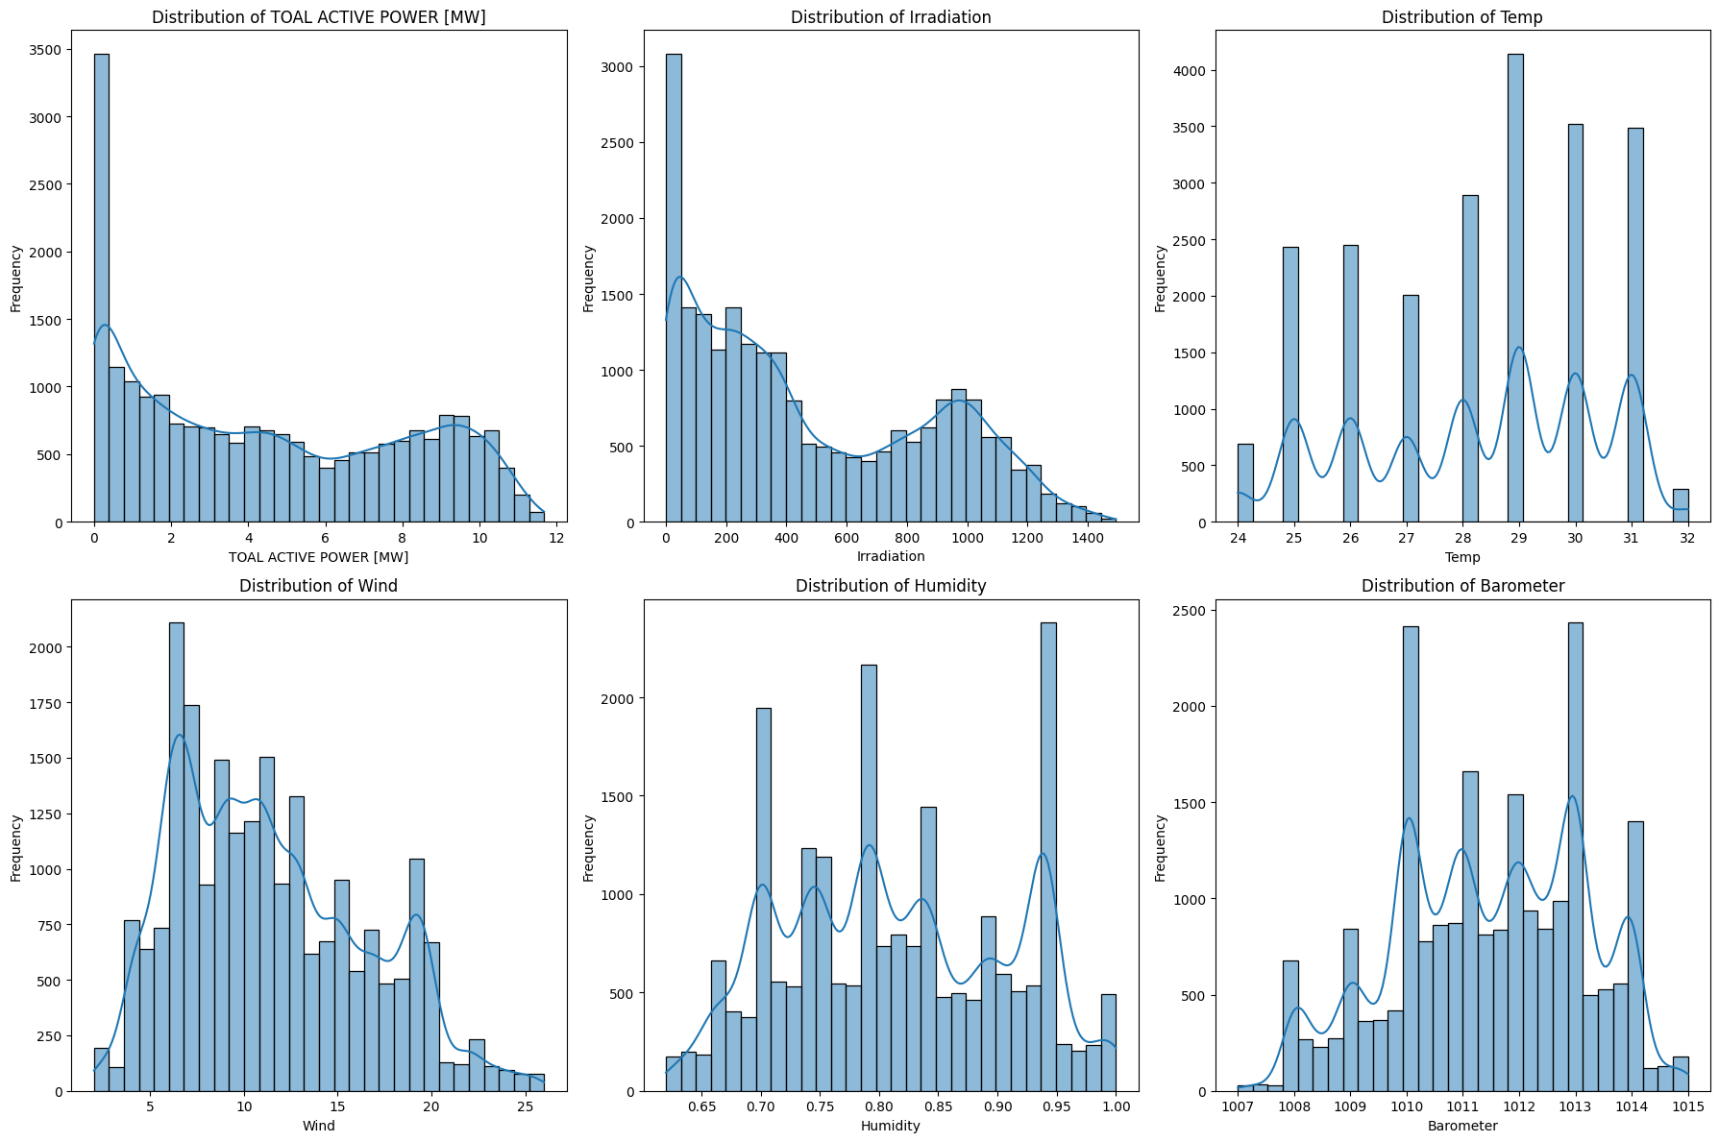

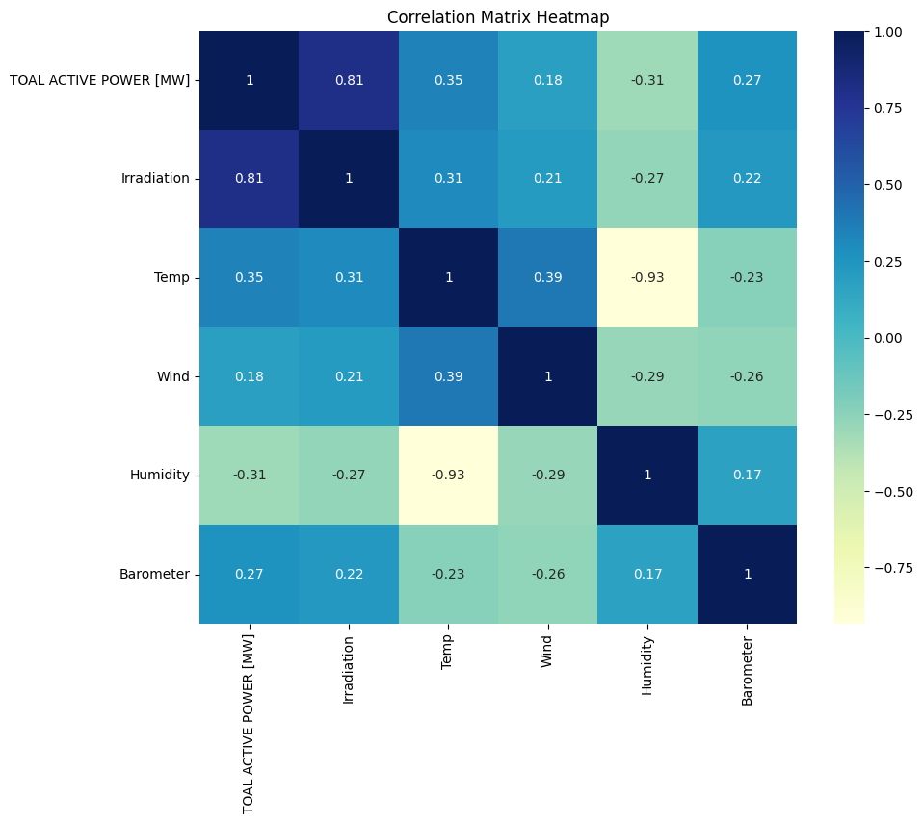

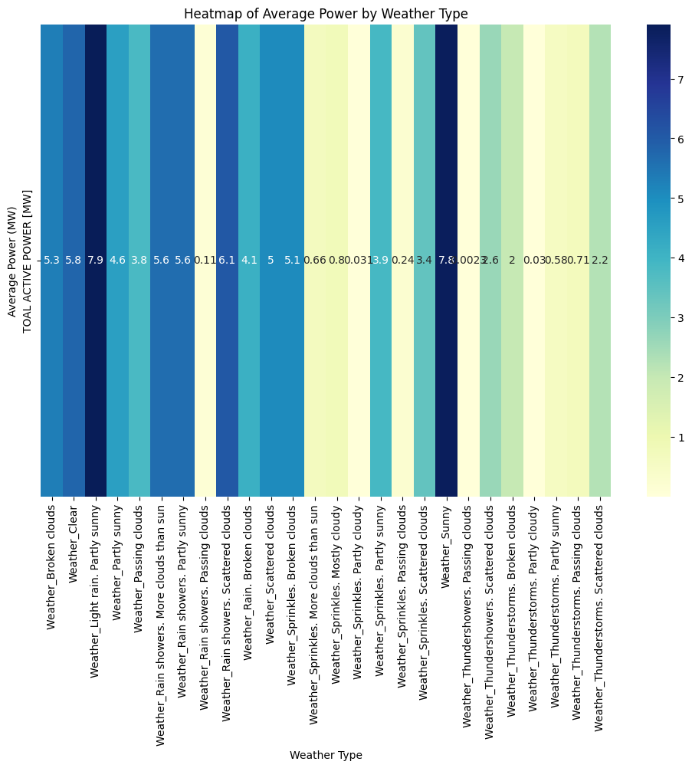

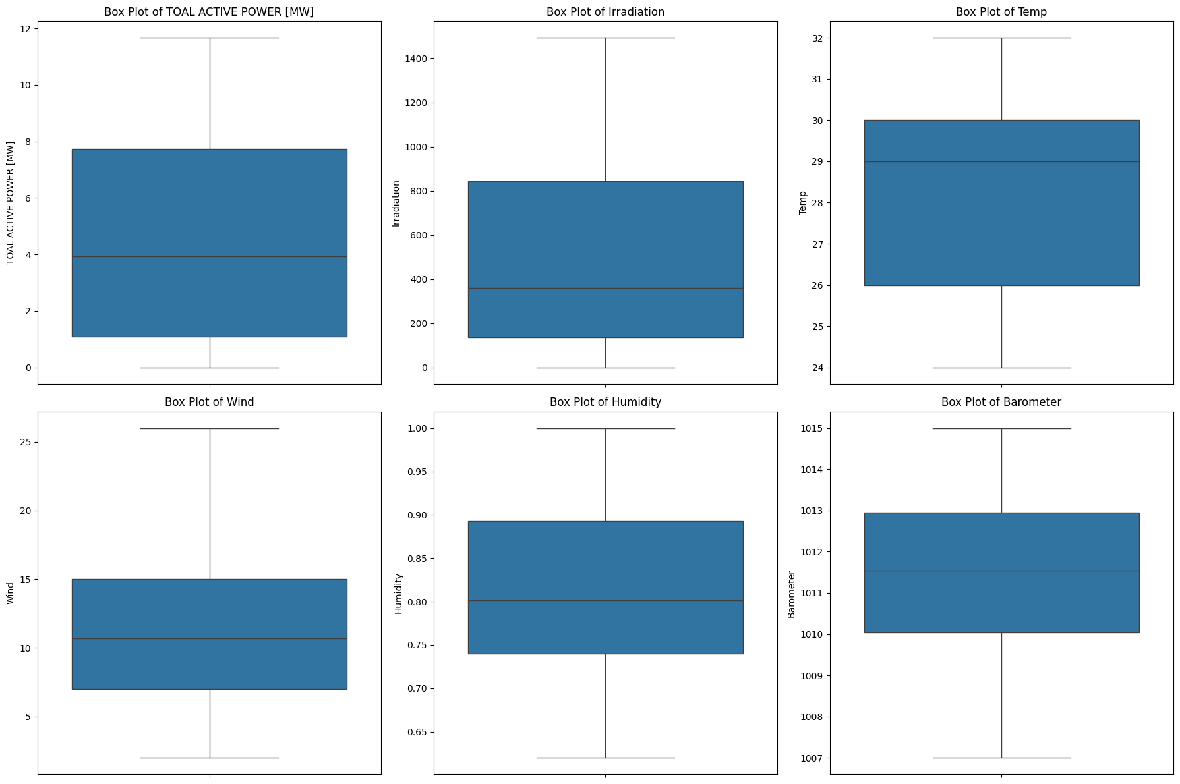

Humidity_lag_1 1.579274

Barometer_lag_2 1.420358

Humidity 0.639662

Humidity_lag_2 0.430433

Temp_lag_2 0.147332

Temp 0.126135

Temp_lag_1 0.072009

Wind_lag_2 0.038271

Barometer_lag_1 0.030300

Irradiation 0.004653

Irradiation_lag_2 0.001707

Irradiation_lag_1 0.000480

Wind_lag_1 -0.000970

Wind -0.044635

Barometer -1.172258

dtype: float64

